Copyright for test papers and marking guides remains with West Australian Test Papers.
Test papers may only be reproduced within the purchasing school according to the advertised Conditions of Sale.
Test papers should be withdrawn after use and stored securely in the school until Friday June 16th 2017.


MATHEMATICS
SPECIALIST
UNIT 3

Semester One

2017

SOLUTIONS

Calculator−free Solutions

1. (a) $P\left(2i\right)=2{\left(2i\right)}^{3}-4{\left(2i\right)}^{2}+8\left(2i\right)-16$
$=2\left(-8i\right)-4\left(-4\right)+16i-16$
$=-16i+16+16i-16=0$ as required

(b) $z_{2}=\overline{z_{1}}=-2i$
Using factorisation:
$P\left(z\right)=2(z+2i)(z-2i)(z-k)$
$=2\left(z^{2}+4\right)\left(z-k\right)=2(z^{3}-2z^{2}8z-18)$
$∴k=2$
$∴P\left(z\right)=2(z+2i)(z-2i)(z-2)$

OR using division of polynomials:

 | $$2z$$ | $$-4$$
$$z^{2}+4$$ | $$2z^{3}$$ | $$-4z^{2}$$ | $$+8z$$ | $$-16$$
 | $$2z^{3}$$ |  | $$+8z$$
 | $$0$$ | $$-4z^{2}$$ | $$0$$ | $$-16$$
 |  | $$-4z^{2}$$ |  | $$-16$$
 |  | $$0$$ |  | $$0$$
$∴P(z)=\left(z^{2}+4\right)\left(2z-4\right)=2(z+2i)(z-2i)(z-2)$ [6]

2. (a) $f\left(z\right)=z^{5}-32i=0$
$z^{5}=32i=32\operatorname{cis}\left(\frac{π}{2}+2πk\right)$ with $k=0,±1,±2$
$∴z=2\cos\left(\frac{π + 4πk}{10}\right)$ with $k=0,±1,±2$
hence,
$k=0 → z_{0}=2\cos\left(\frac{π}{10}\right)$
$k=1 → z_{1}=2\cos\left(\frac{π}{2}\right)$
$k=-1→ z_{2}=2\cos\left(-\frac{3π}{10}\right)$
$k=2 → z_{3}=2\cos\left(\frac{9π}{10}\right)$
$k=-2→ z_{0}=2\cos\left(-\frac{7π}{10}\right)$

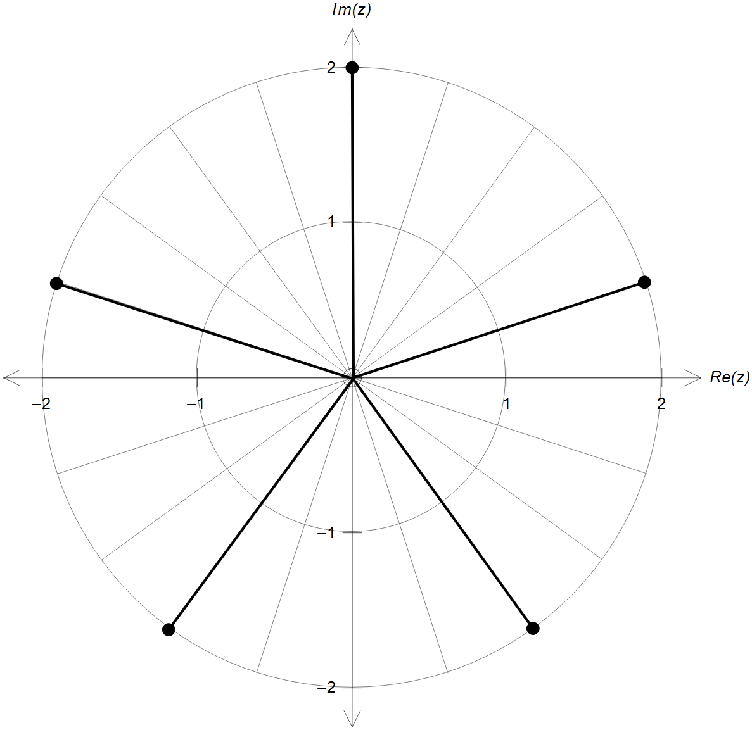2. (b)

magnitude = 2

$\frac{2π}{5}$ radians apart

[6]

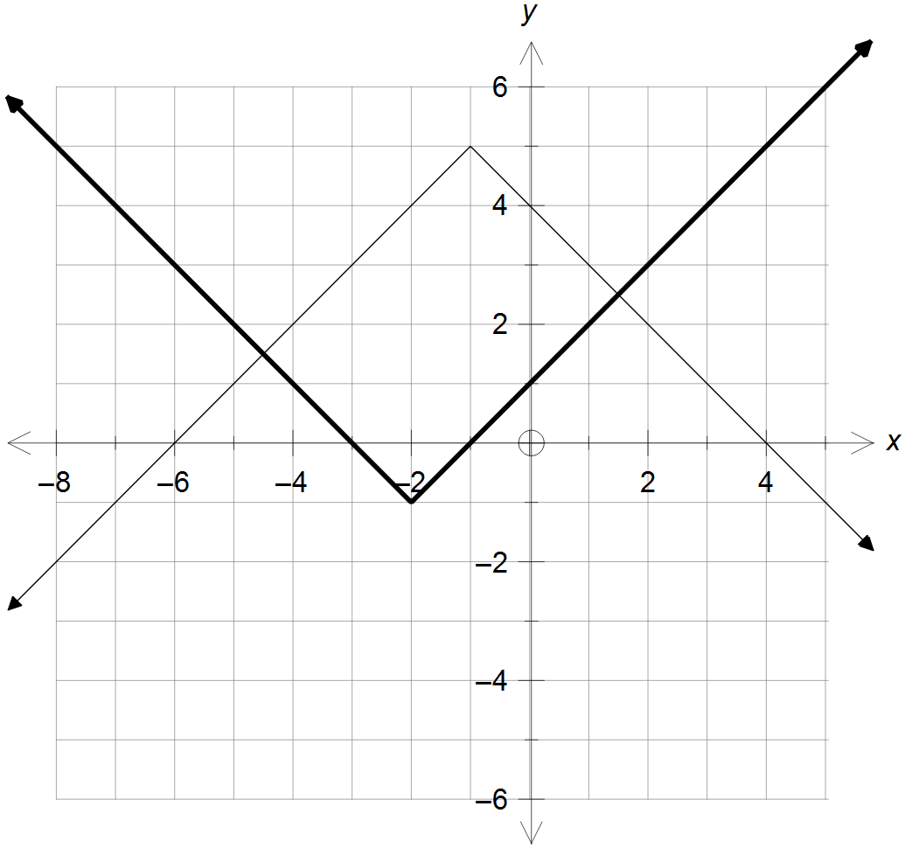
3. (a)

correct x position

correct y position

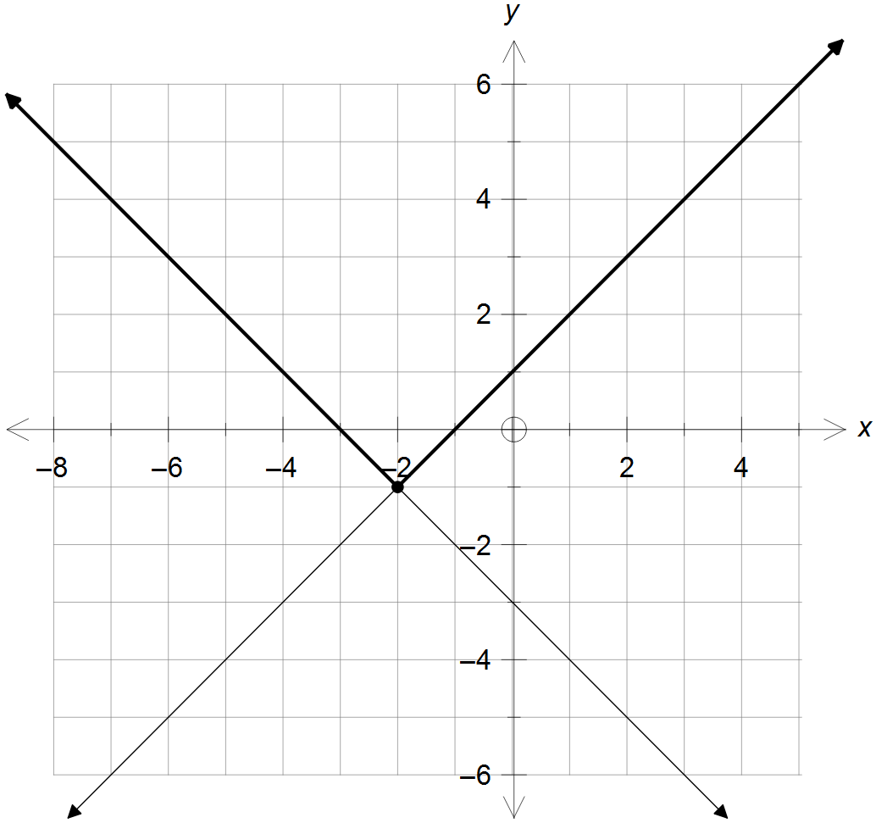
(b) (i)

$y=-1-\left|x+2\right|$
$∴a=-1$ and $b=2$
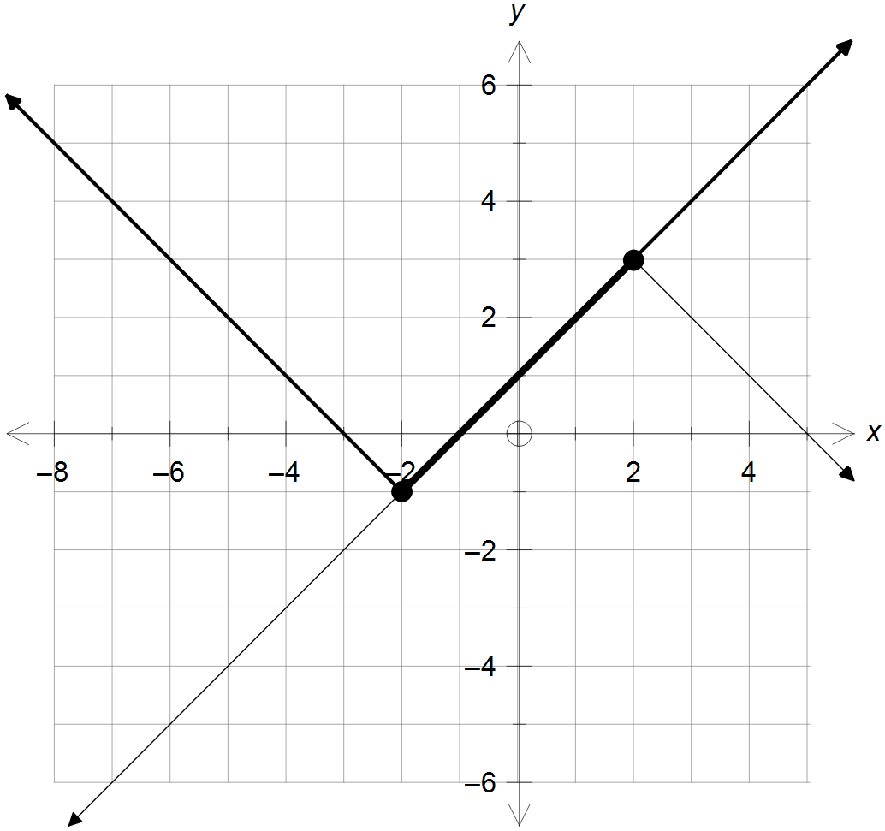3. (b) (ii)

$y=3-\left|x-2\right|$
$∴a=3$ and $b=-2$ [2]

4. (a) $h\left(x\right)=f\left(f(x)\right)=\frac{1}{1+f(x)}$ with $x≠-1$
$∴1+f\left(x\right)≠0$
$f\left(x\right)=\frac{1}{1 + x}≠-1$
$∴x≠-2$ and $x≠-1$
$f(x)≠0$ on its natural domain, hence
$f\left(0\right)=1$ will not be generated by the second $f(x)$
$∴ \left\{y: y≠1 and y≠0\right\}$

(b) $h\left(x\right)=\frac{1}{1+\left(\frac{1}{1+x}\right)}=\frac{1}{\frac{1+x+1}{1+x}}=\frac{x+1}{x+2}$
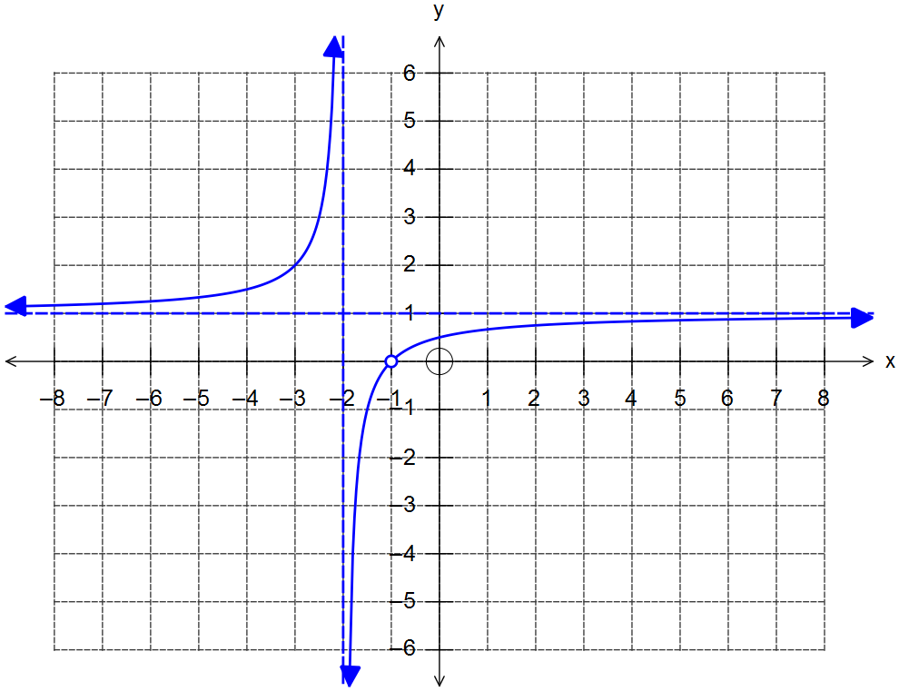 $∴h\left(x\right)=\frac{x+2-1}{x+2} = \frac{x+2}{x+2}-\frac{1}{x+2} = \frac{-1}{x+2}+1$

asymptotes
x = -2 and y = 1

discontinuity at
x = -1

correct shape
4. (c) $x=1-\frac{1}{y+2}$
$∴y=\frac{-1}{x+1}-2=\frac{1 - 2x}{x - 1}$
Domain $\left\{x:x≠1, x≠0\right\}$
Range $\left\{y:y≠-2, y≠-1\right\}$ [12]

5. (a) Cartesian equations of the planes:
$\begin{matrix}2x+y+z=1 \\ 4y+2z=2 \\ 3x+y-z=8\end{matrix}$
Using matrices:
$\left[ \begin{matrix}\begin{matrix}\begin{matrix}2 \\ 0 \\ 3\end{matrix} & \begin{matrix}1 \\ 4 \\ 1\end{matrix}\end{matrix} & \begin{matrix}\begin{matrix}1 \\ 2 \\ -1\end{matrix} & \begin{matrix}1 \\ 2 \\ 8\end{matrix} \end{matrix}\end{matrix}\right]\begin{matrix}R_{1} \\ R_{2} \\ R_{3}\end{matrix}$
$\left[ \begin{matrix}\begin{matrix}\begin{matrix}2 \\ 0 \\ 0\end{matrix} & \begin{matrix}1 \\ 2 \\ -1\end{matrix}\end{matrix} & \begin{matrix}\begin{matrix}1 \\ 1 \\ -5\end{matrix} & \begin{matrix}1 \\ 1 \\ 13\end{matrix} \end{matrix}\end{matrix}\right]\begin{matrix}R_{1} \\ \frac{1}{2}R_{2} \\ 2R_{3}-3R_{1}\end{matrix}$
$\left[ \begin{matrix}\begin{matrix}\begin{matrix}2 \\ 0 \\ 0\end{matrix} & \begin{matrix}1 \\ 2 \\ 0\end{matrix}\end{matrix} & \begin{matrix}\begin{matrix}1 \\ 1 \\ -9\end{matrix} & \begin{matrix}1 \\ 1 \\ 27\end{matrix} \end{matrix}\end{matrix}\right]\begin{matrix}R_{1} \\ R_{2} \\ R_{2}+2R_{3}\end{matrix}$
$∴-9z=27$, $z=-3$
$2y-3=1$, $y=2$
$2x+2-3=1$, $x=1$
Unique solution: $\left(1, 2, -3\right)$

(b) Fully simplified matrix in terms of $a$:

$\left[ \begin{matrix}\begin{matrix}\begin{matrix}2 \\ 0 \\ 0\end{matrix} & \begin{matrix}1 \\ 2 \\ 0\end{matrix}\end{matrix} & \begin{matrix}\begin{matrix}1 \\ 1 \\ \left(4a-5\right)\end{matrix} & \begin{matrix}1 \\ 1 \\ 27\end{matrix} \end{matrix}\end{matrix}\right]$

$∴4a-5=0$
$a≠\frac{5}{4}$ [6]
(Algebraic manipulation and substitution is also acceptable)

6. (a) Midpoint between $\left(\begin{matrix}0 \\ -4 \\ 0\end{matrix}\right)$ and $\left(\begin{matrix}4 \\ 0 \\ -4\end{matrix}\right)$ is $\left(\begin{matrix}2 \\ -2 \\ -2\end{matrix}\right)$
OR $\vec{AG}=\left(\begin{matrix}4 \\ 4 \\ -4\end{matrix}\right)$, centre = $\vec{OA}+\frac{1}{2}\vec{AG}=\left(\begin{matrix}0 \\ -4 \\ 0\end{matrix}\right)+\frac{1}{2}\left(\begin{matrix}4 \\ 4 \\ -4\end{matrix}\right)=\left(\begin{matrix}2 \\ -2 \\ -2\end{matrix}\right)$
radius = $\frac{1}{2}\left|\vec{AG}\right|=\frac{1}{2}\left|\begin{matrix}4 \\ 4 \\ -4\end{matrix}\right|=2\left|\begin{matrix}1 \\ 1 \\ -1\end{matrix}\right|=2\sqrt{3}$ units
$\left|r-\left(\begin{matrix}2 \\ -2 \\ -2\end{matrix}\right)\right|=2\sqrt{3}$

(b) $\vec{AF}=\left(\begin{matrix}4 \\ 0 \\ -4\end{matrix}\right), \vec{AB}=\left(\begin{matrix}4 \\ 4 \\ 0\end{matrix}\right)$
$\vec{AF}×\vec{AB}=\left(\begin{matrix}0+16 \\ -16-0 \\ 16-0\end{matrix}\right)=\left(\begin{matrix}16 \\ -16 \\ 16\end{matrix}\right)=16\left(\begin{matrix}1 \\ -1 \\ 1\end{matrix}\right)$
$k=\left(\begin{matrix}4 \\ 0 \\ 0\end{matrix}\right)∙\left(\begin{matrix}1 \\ -1 \\ 1\end{matrix}\right)=4$
$∴r∙\left(\begin{matrix}1 \\ -1 \\ 1\end{matrix}\right)=4$ [8]

7. (a) $x=2\cos{t} → \cos{t}=\frac{x}{2}$
$\sin^{2}{t}+\cos^{2}{t}=y^{2}+\frac{x^{2}}{4}=1$
(b) $x=1 → 2\cos{t}=1, ∴t=\frac{π}{3}$
$\dot{r}\left(t\right) =-2\sin{t}i+\cos{t}j$
$=-2\sin\left(\frac{π}{3}\right)i+\cos\left(\frac{π}{3}\right)j$
$=-\sqrt{3}i+\frac{1}{2}j$
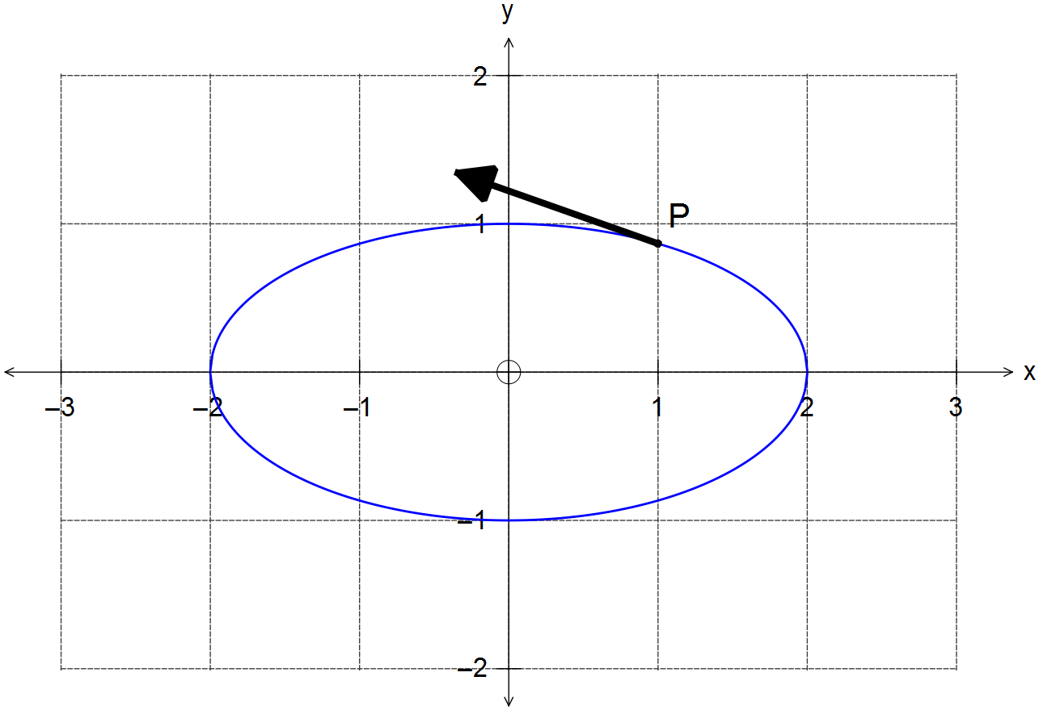

[6]

Calculator−Assumed Solutions

8. (a) $x=2$ and $y=-\frac{x}{2}+1$
(b) $f\left(x\right)=\frac{k}{x-2}+\left(-\frac{x}{2}+1\right)$
$f\left(3\right)=\frac{k}{1}+1-\frac{3}{2}=\frac{3}{2} → k=2$
$∴f\left(x\right)=\frac{2}{x-2}-\frac{x}{2}+1=\frac{-x^{2}+4x}{2x-4}$
$∴ a=-1, b=4, c=0, m=2, n=-4$ [6]

9. (a) $v\left(t\right)=\int{\left[\left(6t\right)i+2j\right]dt}=\left(3t^{2}+A\right)i+\left(2t+B\right)j$
$v\left(0\right)=\left(\begin{matrix}0+A \\ 0+B\end{matrix}\right)=\left(\begin{matrix}-2 \\ -3\end{matrix}\right)$
$∴ v\left(t\right)=\left(3t^{2}-2\right)i+\left(2t-3\right)j$

$r\left(t\right)=\int{\left[\left(3t^{2}-2\right)i+\left(2t-3\right)j\right]dt}$
$=\left(t^{3}-2t+C\right)i+\left(t^{2}-3t+D\right)j$
$r\left(0\right)=\left(\begin{matrix}0+C \\ 0+D\end{matrix}\right)=\left(\begin{matrix}0 \\ 0\end{matrix}\right)$
$∴ r\left(t\right)=\left(t^{3}-2t\right)i+\left(t^{2}-3t\right)j$

(b) Condition to stop:
$\left|v(t)\right|=\left|\begin{matrix}3t^{2}-2 \\ 2t-3\end{matrix}\right|=0$
$∴t=±\sqrt{\frac{2}{3}}$ for x axis and $t=\frac{3}{2}$ for y axis
Since there is no unique solution, the particle does
not come to a stop.

(c) Motion parallel to x axis = no y axis velocity
$∴2t-3=0 → t=\frac{3}{2}$ seconds
$∴\left|v\left(\frac{3}{2}\right)\right|=\left|\begin{matrix}3{\left(\frac{3}{2}\right)}^{2}-2 \\ 0\end{matrix}\right|=\frac{19}{4}=4.75$ ms⁻¹
$r\left(\frac{3}{2}\right)=\left(\begin{matrix}{\left(\frac{3}{2}\right)}^{3}-2\left(\frac{3}{2}\right) \\ {\left(\frac{3}{2}\right)}^{2}-3\left(\frac{3}{2}\right)\end{matrix}\right)=\left(\begin{matrix}\frac{3}{8} \\ -\frac{9}{4}\end{matrix}\right)=\frac{3}{8}i-\frac{9}{4}j$ [11]

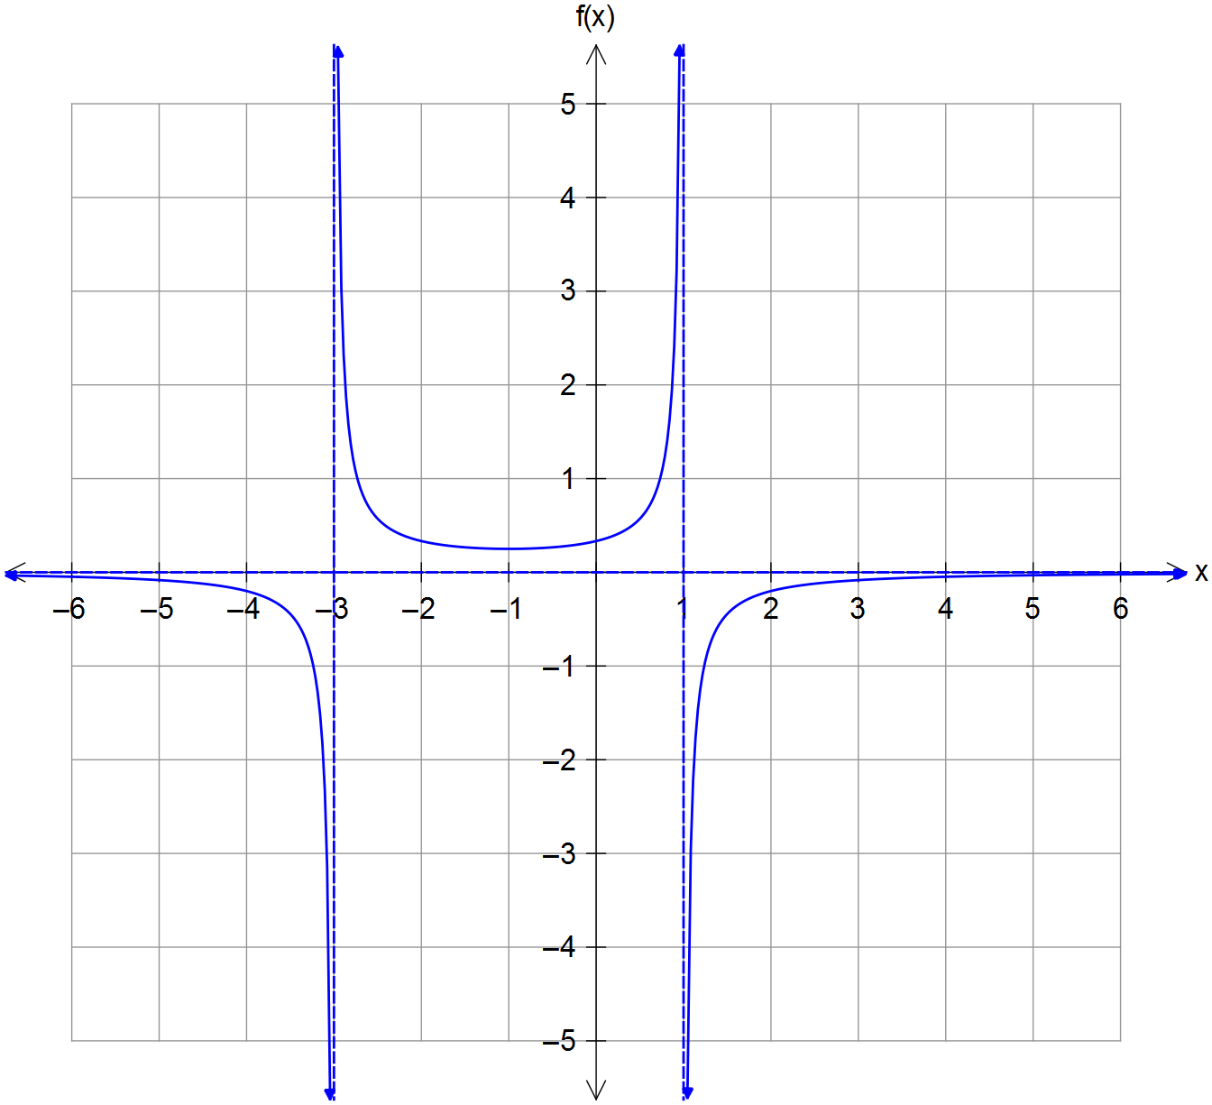10. (a)

Vertical asymptotes
x = -3, x = 1

Indicates y → 0⁻
as |x| → ∞

Shows local min
at x = -1

Correct curvature at
x = -3 and x = 1

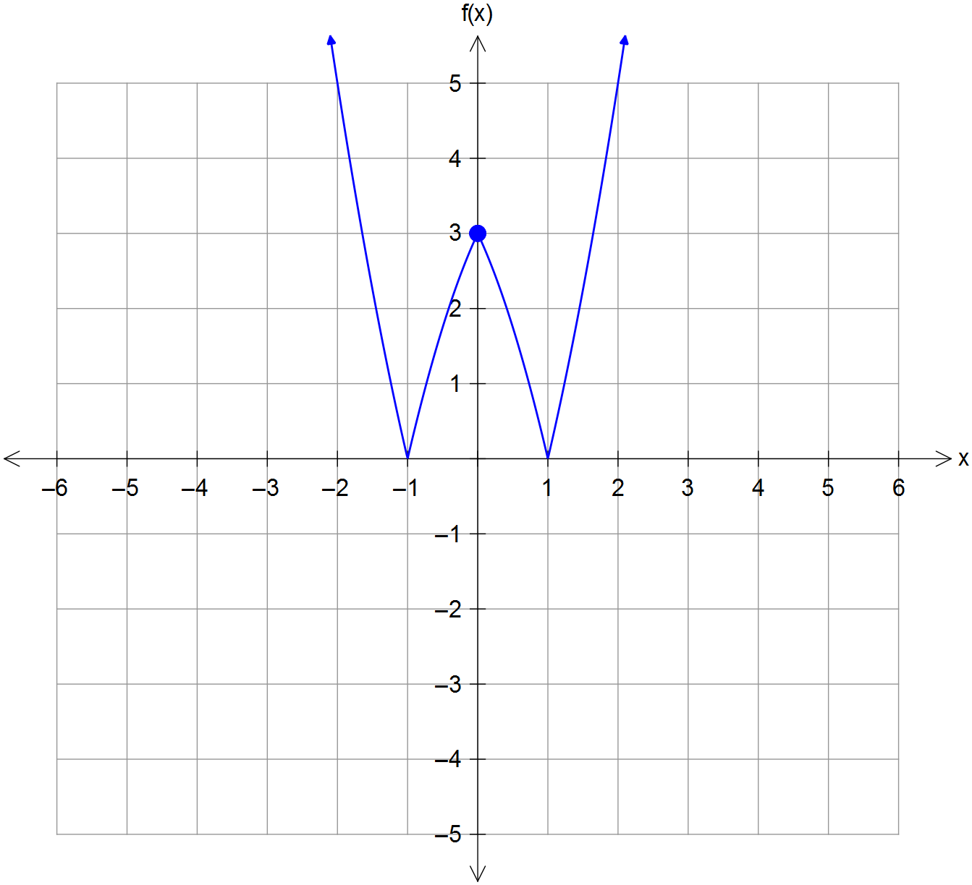 (b)

Correct mirror image
over x axis

Correct mirror image
over y axis

Indicates points
(0,3),(-1,0) and (1,0)

(c) Function can be inverted about its turning point.
i.e., for $x=-1 → ∴k=-1$
Domain $\left\{x:x≤4\right\}$
Range $\left\{y:y≥-1\right\}$ [10]

11. (a) At the xz plane y = 0.
$∴x^{2}+z^{2}-2x=7$
${\left(x-1\right)}^{2}+z^{2}=8$
circle centred at $\left(1, 0\right)$ and radius $2\sqrt{2}$ units

(b) Completing the squares of the original sphere:
${\left(x-1\right)}^{2}+{\left(y+1\right)}^{2}+z^{2}=9$
$∴ \left|r-\left(\begin{matrix}1 \\ -1 \\ 0\end{matrix}\right)\right|=3$
centre of sphere is $C\left(1, -1, 0\right)$
$∴n=\vec{CP}=\left(\begin{matrix}3 \\ 1 \\ 1\end{matrix}\right)-\left(\begin{matrix}1 \\ -1 \\ 0\end{matrix}\right)=\left(\begin{matrix}2 \\ 2 \\ 1\end{matrix}\right)$
$k=n∙\vec{OP}=\left(\begin{matrix}2 \\ 2 \\ 1\end{matrix}\right)∙\left(\begin{matrix}3 \\ 1 \\ 1\end{matrix}\right)=6+2+1=9$
$∴r∙\left(\begin{matrix}2 \\ 2 \\ 1\end{matrix}\right)=9$ and hence $2x+2y+z=9$ [8]

12. (a) $F\left(x\right)={\left[\cos\left(1-x\right)\right]}^{2}=f\left[\cos\left(1-x\right)\right]=f\left[g\left(1-x\right)\right]=f\left[g\left(h\left(x\right)\right)\right]$
$∴f\left(x\right)=x^{2}, g\left(x\right)=\cos{x}, h\left(x\right)=1-x$

(b) (i) $f\left(g\left(1\right)\right)=f\left(2\right)=3$
$f\left(f\left(-3\right)\right)=f\left(0\right)=-3$
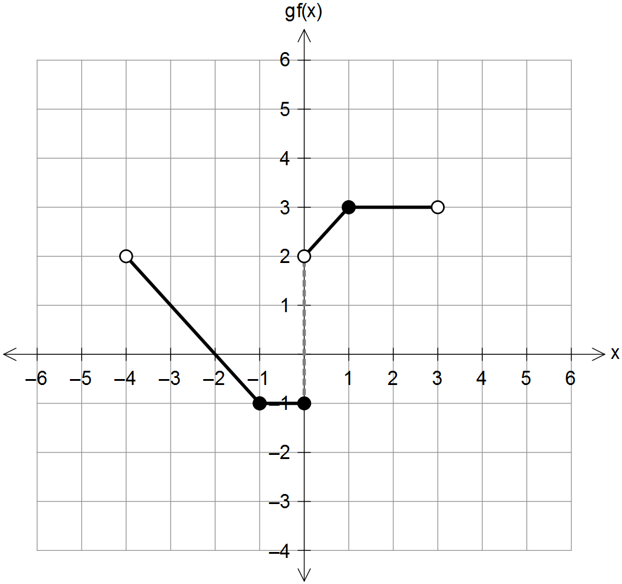
(ii)

correct sections

correct y-intersect

correct discontinuities

[8]
13. (a) $\left|z+2\right|≤\left|z-2+2i\right|$

(b) $r≤θ ∴$ region under spiral
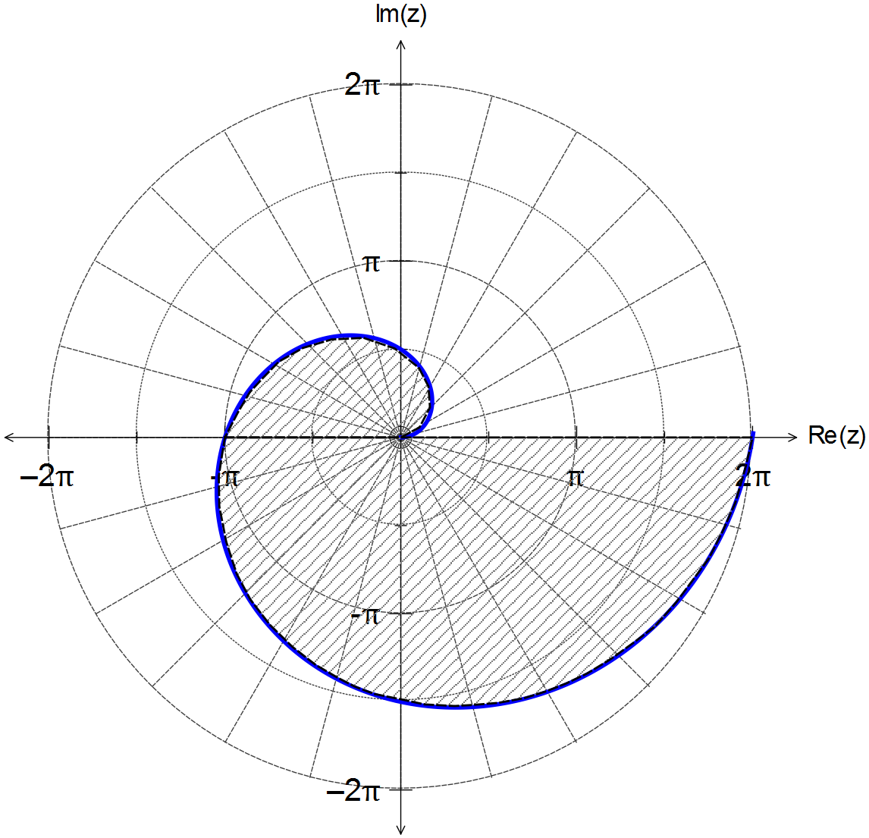

spiral r = θ

region under spiral
and x axis

(b) $\frac{z+1}{z+i}=\frac{\left(x+1\right)+yi}{x+i\left(y+1\right)}$ such that $z≠-i$
CAS: $=\left(\frac{x^{2}+y^{2}+x+y}{x^{2}+{\left(y+1\right)}^{2}}\right)+i\left(\frac{-x-y-1}{x^{2}{\left(y+1\right)}^{2}}\right)$
$Arg\left(\frac{z+1}{z+i}\right)=\frac{π}{4} → Re\left(\frac{z+1}{z+i}\right)=Im\left(\frac{z+1}{z+i}\right)$
$∴x^{2}+y^{2}+x+y=-x-y-1$
${\left(x+1\right)}^{2}+{\left(y+1\right)}^{2}=1$
circle centred at $\left(1, 1\right)$ and radius $r=1$
with discontinuity at $z=-i$
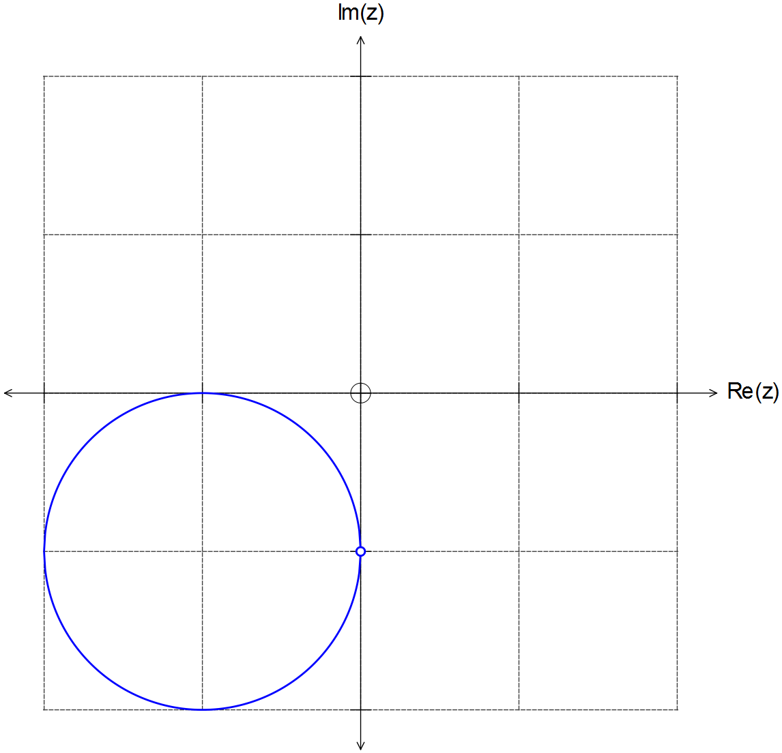

[10]

14. (a) height = vertical velocity × time = 90 × 4 = 360 m

(b) Detonation at $\vec{OA}=\left(\begin{matrix}80 \\ -120 \\ 0\end{matrix}\right)+4\left(\begin{matrix}30 \\ -10 \\ 90\end{matrix}\right)=\left(\begin{matrix}200 \\ -160 \\ 360\end{matrix}\right)$
$\vec{AP}=\vec{OP}-\vec{OA}=\left(\begin{matrix}-200 \\ 350 \\ 20\end{matrix}\right)-\left(\begin{matrix}200 \\ -160 \\ 360\end{matrix}\right)=\left(\begin{matrix}-400 \\ 510 \\ -340\end{matrix}\right)$
direct distance = $\left|\vec{AP}\right|=\left|\begin{matrix}-400 \\ 510 \\ -340\end{matrix}\right|=731.92$ m
time difference $=\frac{731.92}{340}=2.15$ seconds

(c) speed $=\left|\begin{matrix}30 \\ -10 \\ 90\end{matrix}\right|=10\sqrt{91}=95.39$ ms⁻¹
projection vector onto xy plane $=\left(\begin{matrix}30 \\ -10 \\ 0\end{matrix}\right)$
$∴ \left(\begin{matrix}30 \\ -10 \\ 0\end{matrix}\right)∙\left(\begin{matrix}30 \\ -10 \\ 90\end{matrix}\right)=\left|\begin{matrix}30 \\ -10 \\ 0\end{matrix}\right|×\left|\begin{matrix}30 \\ -10 \\ 90\end{matrix}\right|×\cos{θ}$
$∴\cos{θ}=\frac{10}{\sqrt{910}} → θ=70.64°$

(d) distance vector $=\left(\begin{matrix}200 \\ -160 \\ 360\end{matrix}\right)-\left(\begin{matrix}120 \\ -40 \\ 0\end{matrix}\right)=\left(\begin{matrix}80 \\ -120 \\ 360\end{matrix}\right)$
velocity $=\frac{1}{4}\left(\begin{matrix}80 \\ -120 \\ 360\end{matrix}\right)=\left(\begin{matrix}20 \\ -30 \\ 90\end{matrix}\right)$ ms⁻¹ [11]

15. (a) (i)
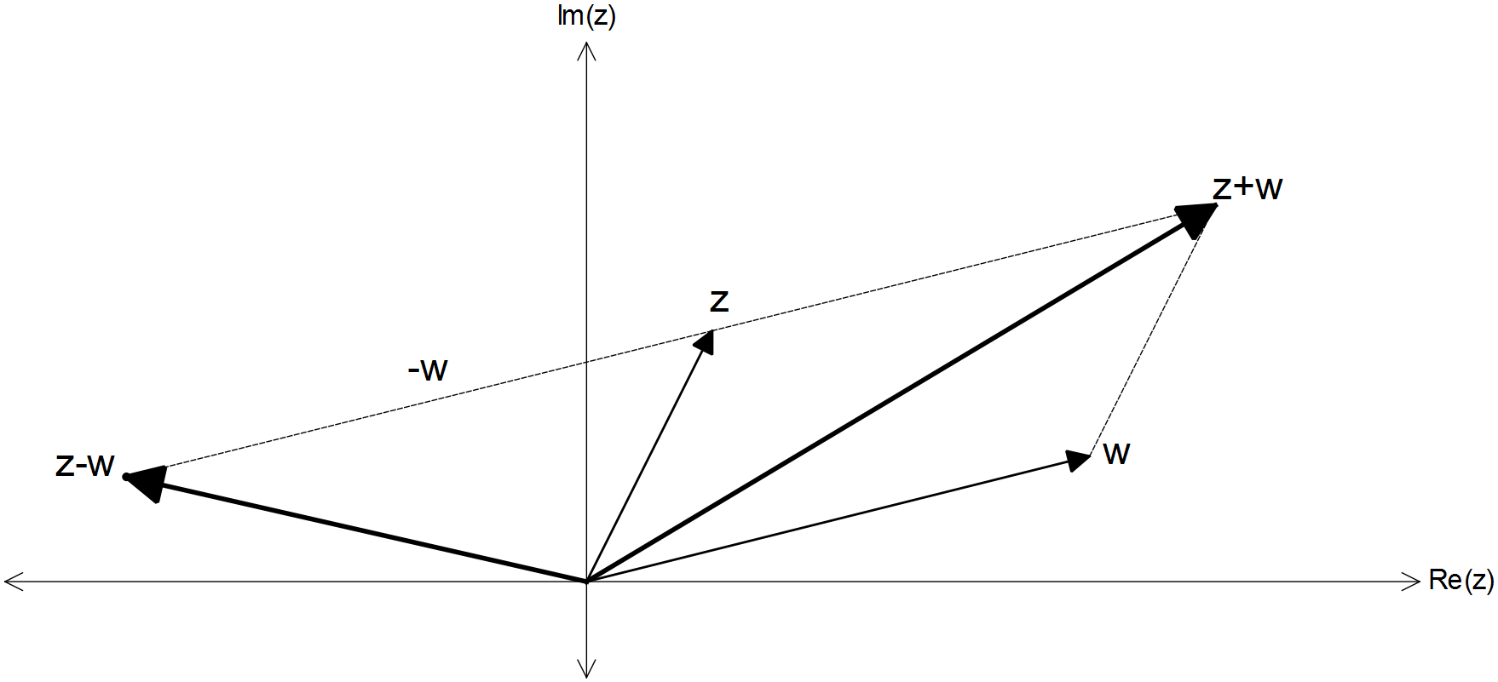

z + w

z – w in the
correct location

15. (a) (ii) ${\left|z+w\right|}^{2}={\left|z-w\right|}^{2}$
${\left(z+w\right)}^{2}={\left(z-w\right)}^{2}$
$z^{2}+2zw+w^{2}=z^{2}-2zw+w^{2}$
$4zw=0$ and hence $wz=0$
if $z, w$ are treated as vectors, then $z⊥w$
and hence $\left|\arg\left(z\right)-arg⁡(w)\right|=\frac{π}{2}$

(b) Let $u=x+yi$
${\left|i+x+yi\right|}^{2}+{\left|i-x-yi\right|}^{2}$
$={\left(\sqrt{x^{2}+{\left(y+1\right)}^{2}}\right)}^{2}+{\left(\sqrt{{\left(-x\right)}^{2}+{\left(1-y\right)}^{2}}\right)}^{2}$
$=x^{2}+y^{2}+2y+1+x^{2}+1-2y+y^{2}$
$=2+2\left(x^{2}+y^{2}\right)=2+2\left(1\right)=4$

(c) (i) $iz^{2}=\operatorname{cis}\left(\frac{π}{2}\right)r^{2}\operatorname{cis}\left(2θ\right)=r^{2}\operatorname{cis}\left(2θ+\frac{π}{2}\right)$
$∴ \left|iz^{2}\right|=r^{2}$ and $\arg\left(iz^{2}\right)=2θ+\frac{π}{2}$

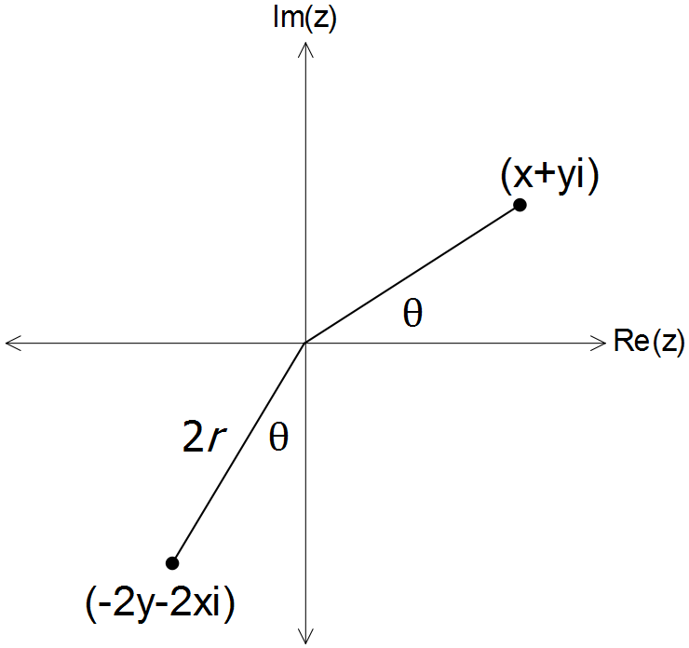
(ii)

$∴ \left|-2y-2xi\right|=\left|-2\left(y+xi\right)\right|=2 r$
$arg\left(-2y-2xi\right)=-\left(θ+\frac{π}{2}\right)$ [14]

16. (a) CAS $→ Q\left(z\right)=z^{2}+z-1$
(OR, using division of polynomials)

(b) $\left(z^{3}+1\right)\left(z^{2}+z-1\right)=0$
$z^{3}=-1$
$∴z_{1}=-1, z_{2}=\frac{1}{2}+\frac{i\sqrt{3}}{2}, z_{3}=\frac{1}{2}-\frac{i\sqrt{3}}{2}$
$z=\frac{-1±\sqrt{1+4}}{2}$
$∴z_{4}=\frac{-1+\sqrt{5}}{2}, z_{5}=\frac{-1-\sqrt{5}}{2}$ [7]

17. (a) By De Moivre’s theorem
${\left(\cos{θ}+i\sin{θ}\right)}^{4}=\cos\left(4θ\right)+i\sin\left(4θ\right)$
$=\cos^{4}{θ}+4i\sin{θ}\cos^{3}{θ}-6\sin^{2}{θ}\cos^{2}{θ}-4i\cos{θ}\sin^{3}{θ}+\sin^{4}{θ}$
$∴\cos\left(4θ\right)=Re\left[{\left(\cos{θ}+i\sin{θ}\right)}^{4}\right]$
$=\cos^{4}{θ}-6\sin^{2}{θ}\cos^{2}{θ}+\sin^{4}{θ}$
$=\cos^{4}{θ}-6\cos^{2}{θ}\left(1-\cos^{2}{θ}\right)+{\left(1-\cos^{2}{θ}\right)}^{2}$
$∴\cos\left(4θ\right)=8\cos^{4}{θ}-8\cos^{2}{θ}+1$

(b) Let $x=\cos{θ}$, then
$8x^{4}-8x^{2}+1=0$ when $\cos{4θ}=0$
$∴4θ=\frac{π}{2},\frac{3π}{2},\frac{5π}{2},\frac{7π}{2}$
and $∴θ=\frac{π}{8},\frac{3π}{8},\frac{5π}{8},\frac{7π}{8}$
$∴x=\cos{\frac{π}{8}},\cos{\frac{3π}{8}},\cos{\frac{5π}{8}},\cos{\frac{7π}{8}}$ [8]

18. (a) If the dot product is zero, then $a$ is perpendicular to
the plane normal to $b$ and $c$.
If the cross product is zero, then $b$ and $c$ are parallel

(b) LHS $=\left(a+b\right)×\left(a-b\right)$
$=a×a-a×b+b×a-b×b$
$=0-\left(-\left(b×a\right)\right)+b×a-0$
$=b×a+b×a$
$=2\left(b×a\right)=$ RHS [7]

